C u r r i c u l u m

|  |  |
| --- | --- |
| **CPR NO.**  **Nationality** | **911106545**  **Bahraini** |
| **Date of Birth** | **19. 11. 1991** |
| **Gender** | **Male** |
| **Address** | **House 1880, Road 7526, Janabiya 575** |
| **Telephone** | **66969933 / 39237710** |
| **Marital Status** | **single** |
| **Driving License** | **Full** |
| **Email** | [**h.fateel91@gmail.com**](mailto:h.fateel91@gmail.com) |
|  |  |

V i t a e **Hussein Mohammed Hassan Jaffar Fateel**

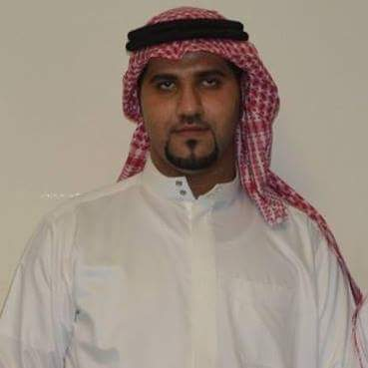

|  |  |
| --- | --- |
| **Objectives / Occupational Goal** | |
| **Objectives** | **Seeking a position that will give me experience and develop my skills and abilities.** |
| **Academic Qualifications** | |
| **2013 - 2018** | **B.Sc. in Accounting and finance**  [***University Of Bahrain (UOB)***](https://services.bahrain.bh/wps/portal/uob_fees_en) |
| **Work Experience** | |
| **(June. 2015 – Present)**  **(Feb. 2013 - Nov. 2014)** | **Checkout supervisors-Lulu Hypermarket SPC**  **cash supervisor – MAF Hypermarkets SPC (Carrefour)** |
| **Skills** | |
| **Computer** | **Microsoft Office applications (MS word, Ms Excel, MS PowerPoint) , Internet and Email** |
| **Interpersonal** | **Quick learner   **  **Ability to work efficiently within team work**  **Able to handle work under pressure** |
| **Languages** | **Arabic – native language**  **English – speak fluently and read/write with high proficiency** |